Topic 9: ‘International conflicts and crises in the 20th century (I) – the two world wars’
Case study：War and Inventions—Medicine
Summary worksheet
According to what you have learnt in lessons (Appendixes B and C) and your own knowledge, complete the following questions.
According to what you’ve learnt in lesson and your own knowledge, how was life of soldiers like in the trenches? How did the military doctors treat the wounded soldiers on the battlefield?
______________________________________________________________________________
Outbreak of war

What are the medical inventions you’ve learnt in lesson?
___________________________________________________________________________

What results did these medical inventions bring?
______________________________________________________________________________

If you were a soldier who survived the war, how would you reflect on the war?
__________________________________________________________________________________________

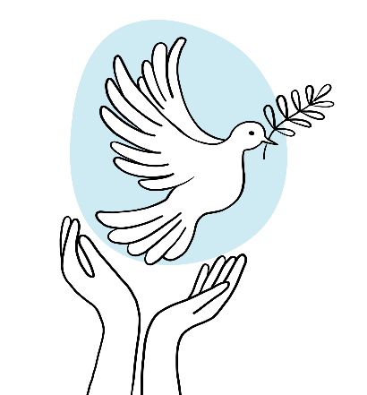
Longing for peace

Topic 9: ‘International conflicts and crises in the 20th century (I) – the two world wars’
Case study：War and Inventions—Medicine
Summary worksheet
According to what you have learnt in lessons (Appendixes B and C) and your own knowledge, complete the following questions
According to what you’ve learnt in lesson and your own knowledge, how was life of the soldiers like in the trenches? How did military doctors treat the wounded soldiers on the battlefield?
Crowded and unhygienic trenches, causing the spread of diseases. The number of casualties is high. Military doctors performed surgery and provided first-aid services for wounded soldiers in the rear of the battlefield.
Outbreak of war

What are the medical inventions you’ve learnt in lesson?
X-ray machines, vaccines, blood transfusion, reconstructive surgeries, ambulance, pill, Thomas splint, penicillin, psychological treatment

What results did these medical inventions bring?
Reduce the casualties in wars

If you were a soldier who survived the war, how would you reflect on the war?
Although the development of medicine was promoted during the war, and the treatment of military doctors can save lives, war still has profound impact over the body and mind of soldiers and civilians, such as disabled affecting future life.

Longing for peace

